Name – Kiranpal Singh

Roll No - RKM018B45

Section – KM018 – INT219

Question 1:

Roll Number – 45



Question 2. Create the following table using jQuery. The colors in different cells must be filled using jQuery only.

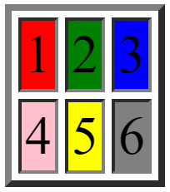

Solution:

Question 3. Insert a button inside a div. Use jQuery to rotate the div upon the click of a button with a transition duration of 2s



Solution: